**Project Report: Employee Attrition Analysis in Power BI**

**By:-**

**Kritika Sharma**

**Summary**

The Employee Attrition Analysis project aims to analyze and understand the factors contributing to employee attrition within an organization. Using Power BI, we have visualized and interpreted key metrics to identify patterns, trends, and potential insights related to employee turnover.

**Objectives**

1. Analyze historical data to identify patterns and trends related to employee attrition.
2. Develop visualizations to represent key metrics such as turnover rates, reasons for attrition, and employee demographics.
3. Provide recommendations based on the analysis to reduce attrition and improve employee retention strategies.

**Data Sources**

**Data Collection**

Data was collected from HR databases, including employee profiles, performance metrics, and exit interviews.

Data cleaning and preprocessing were performed to ensure data accuracy and consistency.

***{data was provided}***

**Data Attributes**

* Employee ID
* Age
* Attrition
* Business Travel
* Department
* Distance From Home
* Education
* Education Field
* Employee Count
* Gender
* Job Level
* Job Role
* Marital Status
* Monthly Income
* Num Companies Worked
* Over18
* Percent Salary Hike
* Standard Hours
* Stock Option Level
* Total Working Years
* Training Times Last Year
* Years At Company
* YearsSinceLastPromotion
* Years With Curr Manager
* Environment Satisfaction
* Job Satisfaction
* Work Life Balance
* Job Involvement
* Performance Rating

**Methodology**

**Data Preparation**

Data was imported into Power BI and transformed using queries and data modeling techniques.

Missing values were handled, and data relationships were established.

**Analysis and Visualization**

Key metrics such as turnover rates, tenure distribution, and turnover reasons were calculated and visualized using various Power BI visualizations (e.g., bar charts, pie charts, heat maps).

Interactive dashboards were created to allow stakeholders to explore data insights dynamically.

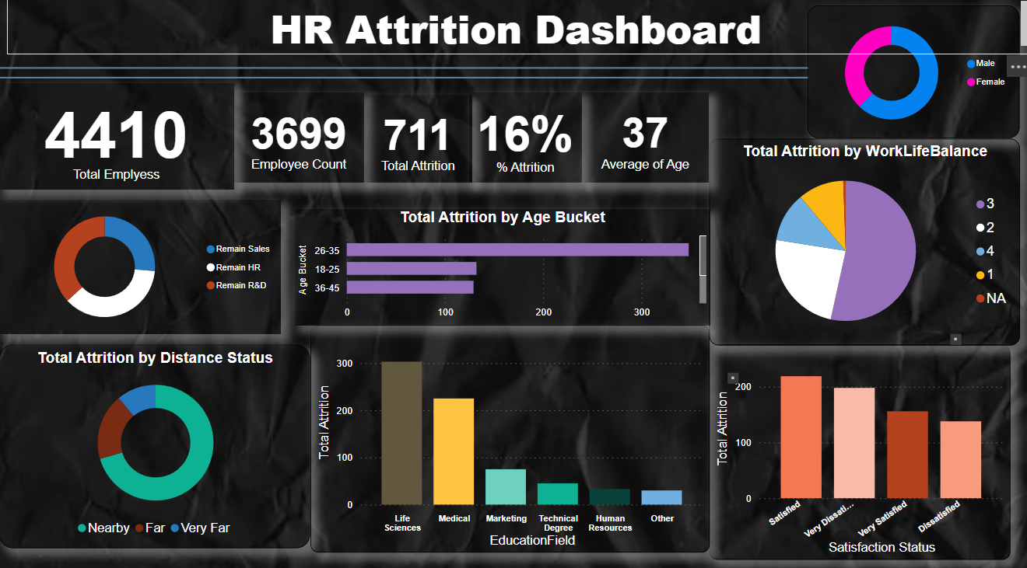



 





**Results**

* **Turnover** **Rates**

Overall turnover rate: X%

Department-wise turnover rates: [Visualization]

Tenure-based turnover analysis: [Visualization]

* **Reasons for Attrition**

Top reasons for employee attrition: [Visualization]

Attrition trends over time: [Visualization]

* **Employee Demographics**

Age distribution of exiting employees: [Visualization]

Gender-based attrition analysis: [Visualization]

**Recommendations**

Based on the analysis, the following recommendations are suggested to address employee attrition:

Implement targeted retention strategies for high-risk departments identified in the analysis.

Conduct regular employee satisfaction surveys to identify and address potential issues proactively.

Provide career development opportunities and mentorship programs to improve employee engagement and loyalty.

Review compensation and benefits packages to ensure competitiveness in the market.

**Conclusion**

The Employee Attrition Analysis project conducted in Power BI has provided valuable insights into the factors contributing to employee turnover. By leveraging data-driven approaches, organizations can make informed decisions and implement strategies to improve employee retention and organizational performance.